**WEEK 8 – ANNOTATION**

Annotation might be considered as time-consuming, detail-oriented, and just plain boring at first, but in fact it isn’t because:

1. Annotations are a record of your thinking. If you’re thinking, make a record of it by writing down what scuttled through your brain.
2. Annotations make remembering your thoughts much easier. In fact, you don’t even have to remember what you thought -- the paper will remember for you!
3. The act of annotating is a physical interaction with the text. Because you’re interacting with the text with both your hands and your eyes, the multisensory experience makes a much stronger imprint on your mind.
4. Annotation is appropriate for ANY subject. It’s not just an English class skill, it’s a reading skill

– and reading happens in every course.

Also, “annotations” means much more than merely highlighting. It is a dynamic way of interacting with the text. In general, annotation refers to two related things:

## Annotating Text Strategies

|  |  |
| --- | --- |
| Within the text or on clear sticky notes, you can use the following tools and techniques for note-taking: | In the margins or on sticky notes, you can write the following information: |
| * Underline * Highlight   •   * Number * Color * Stars or other icons → | * Notes * Thoughts * Summaries and paraphrases * Agreements or disagreements * Definitions * Explanations |

* **Title and author:** What do you know about the subject suggested in the title? What do you know about the author?
* **Headings:** What do headings tell you about the subject? What do they tell you about how the piece is organized?
* **Graphs or tables:** What do graphs or tables tell you? Do they give you information about study results or lead to a conclusion?
* **Introduction and conclusion:** What do the introduction and conclusion tell you about the reading?

## How does an annotated text look like?

* *You don’t need to read the text below in detail. Just have a look at it. It was included only to give you an idea of what an annotated text looks like.*

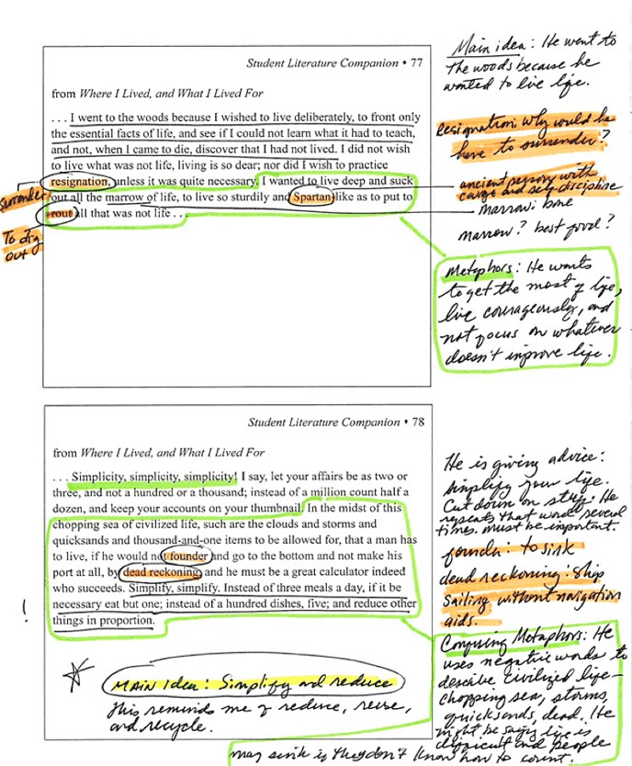

There is no right or wrong way to annotate. You can choose your own annotation style based on what you know or want to know about the text. You can use all the colors you want. You can invent icons for different uses. It’s all up to you.

Effective annotation is a skill that must be developed through practice. It requires thought, planning, and consistency. If you do it well, it will help you to understand and remember what you read. If you don’t do it well, it will do little more than provide you with patches of colored text.

Annotating helps you summarize a text because while you are annotating you pay special attention to the author and title of the text, main ideas and supporting ideas, which you need to include in your summaries.

**Exercise: Annotate Chapter 1 Reading 2 *Press Release from Aeryon Labs. (Leap p.15)***

*Directions:*

Underline and/or circle important words, sentences, and ideas.

Be sure to use marginal spaces to keep track of WHY you’re making marks on the text. While reading, be sure to consider the following:

-What’s the main idea?

-What are the supporting ideas?

-What ideas do I agree with? Disagree with?

Also: Write notes about the key points of each paragraph in the margin using as few words as possible.

## Key Points:

## 1. _____________________________________________________________________

## 2. _____________________________________________________________________

## 3. _____________________________________________________________________

## 4. _____________________________________________________________________

## 5. _____________________________________________________________________

[https://w](http://www.sadlier.com/)ww.sadli[er.com/](http://www.sadlier.com/)

<http://www.teachhub.com/how-annotation-reshapes-student-reading> [https://w](http://www.texasgateway.org/resource/annotating-deepen-understanding-english-iii-reading)ww.te[xasg](http://www.texasgateway.org/resource/annotating-deepen-understanding-english-iii-reading)ate[way.org/resource/annotating-deepen-understanding-english-iii-reading](http://www.texasgateway.org/resource/annotating-deepen-understanding-english-iii-reading)

<http://www.collegewood.org/ourpages/auto/2014/8/17/63598523/Beyond%20the%20Yellow%20Hi> ghlighter.pdf

https://docs.google.com/document/d/1xO6JcQvnXAJNsOd-dkau265az358tNICLCGySCcD0Jc/edit Hoerl, Alexandra. "How to Annotate Texts." LitCharts. LitCharts LLC, 20 Feb 2018. Web. 31 May 2019.